Light and day

During the day the Sun is in the sky.
The light from the Sun is very bright.

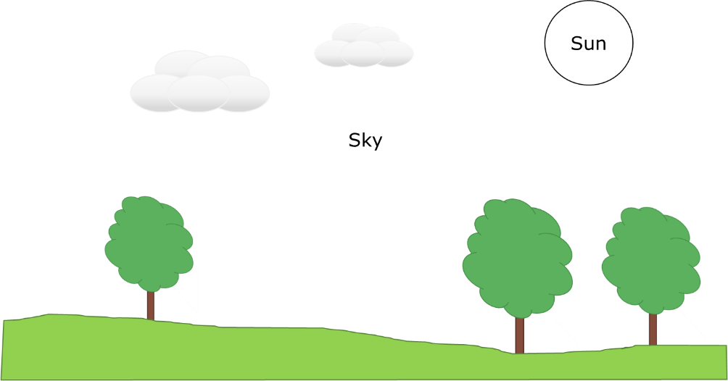

1. What colour is sunlight?
Put a tick (✓) in the box next to the best answer.

A | Yellowish
B | Mixture of yellow, orange and red
C | Blue
D | None of the above
2. What colour is daylight?
Put a tick (✓) in the box next to the best answer.

A | Yellowish
B | Mixture of yellow, orange and red
C | Blue
D | None of the above

Physics > Big idea PSL: Sound, light and waves > Topic PSL2: How we see > Key concept PSL2.2: Seeing in colour
Diagnostic question
Light and day

Overview
Learning focus: | Daylight and sunlight are made from all the colours of the spectrum, which together we see as ‘white light’.
Observable learning outcome: | Describe how sunlight and daylight are different to yellow light.
Question type: | Simple multiple choice
Key words: | Daylight, sunlight

What does the research say?
In a study of 13-year-olds (n=150), 72% did not think that white light was a mixture of different colours (Zylbersztajn and Watts, 1982; Driver et al., 1994). In fact, before encountering ‘white light’ in science lessons fewer than 10% of 13- to 15-year-olds (n=22) understood what ‘white light’ was (Haagen-Schutzenhofer, 2017). 95% of these students described sunlight as yellowish or with a yellow tint. Over half described daylight in a similar way and fewer than one-in-six described daylight as ‘white light’ (ibid.).
This question investigates students’ perceptions of daylight and sunlight in order to challenge any misunderstanding that daylight is yellow. This distinction is important for students in order for them to develop an adequate understanding of white light, which makes ideas of how colour is seen more straightforward.
Ways to use this question
Students should complete the question individually. This could be a pencil and paper exercise, or you could use an electronic ‘voting system’ or mini white boards and the PowerPoint presentation.
The answers to the question will show you whether students understood the concept sufficiently well to apply it correctly.
If there is a range of answers, you may choose to respond through structured class discussion. Ask one student to explain why they gave the answer they did; ask another student to explain why they agree with them; ask another to explain why they disagree, and so on. This sort of discussion gives students the opportunity to explore their thinking and for you to really understand their learning needs.
Differentiation
You may choose to read the questions to the class, so that everyone can focus on the science. In some situations it may be more appropriate for a teaching assistant to read for one or two students.

Equipment
For the class:
- Torch
- Torch with a yellow filter (yellow foil from sweet wrappers works well)
Expected answers
D is the correct answer to both questions.
Sunlight: in a sample of 12- and 13-year-olds it was found that over 90% gave answers like A or B, and none of them gave answer C. The same study found similar results for older secondary students and young adults (Haagen-Schutzenhofer, 2017).
Daylight: in the same study, 50% of 12- and 13-year-olds picked answers like A or B, and almost 20% of older secondary students and young adults gave answer C, but not the younger students. About 40% of 12- and 13-year-olds described daylight as white or colourless, fewer than 10% described sunlight in this way (ibid.).
How to respond - what next?
Culturally the sun is seen as yellow. The times of day when it is easiest to view the Sun are at dawn and dusk, when it is shining through much more of the atmosphere than is usual. At these times the air scatters significant amounts of light from the blue end of the spectrum and so the Sun appears yellow, orange or even red. Seen from outside of the atmosphere the Sun appears white.
Many students link the perceived appearance of the Sun to the colour of sunlight, despite sunlight and daylight being different names for the same thing.
The idea that daylight is blue appears to be linked to the colour of the sky. (This again is caused by the scattering of blue light by the atmosphere.)
If students have misunderstandings about the colour of sunlight or daylight, it can help to demonstrate how they compare to a yellow light. A simple demonstration uses two torches to show the difference: a torch with a ‘plain’ bulb gives light similar to daylight, covering a similar torch with a yellow filter gives yellow light. Shining these near to each other onto a white screen shows that with light similar to daylight, the surface looks white by definition. The white surface does not look white under yellow light.
Acknowledgments
Developed by Peter Fairhurst (UYSEG).
Images: Peter Fairhurst (UYSEG).
References
Driver, R., et al. (1994). Making Sense of Secondary Science: Research into Children's Ideas, London, UK: Routledge.
Haagen-Schutzenhofer, C. (2017). Students' conceptions on white light and implications for teaching and learning about colour. Physics Education, 52.
Zylbersztajn, A. and Watts, D. M. (1982). Throwing some light onto colour. Guildford: Mimeograph, University of Surrey.

